**Ungrading: A Conversation about Alternatives to Traditional Assessments and Grades**

**Assignment Analysis**

To start, consider your current assignment and assessment practices.

How many assignments are there?

Per Week?

Per Unit?

Per Course?

What types of assignments do you use now?

Which assignments do students tend to struggle the most with? Do the best on?

What topics could be assessed differently?

What topics do you think are not assessed well enough?

Why are you considering changing your assessments/assignments?

Additional Resources: *Ungrading*, Susan Blum; JesseStommel.com Michelle Herridge, Ph.D.

Ungrading SET Types of Assignments

|  |  |  |
| --- | --- | --- |
| **Assignment Currently** - What works well?  - What is missing? | **Goals/Learning Objectives**  - What do you want to learn about your students? | **Possible Alternative Assignment**  - How else could you determine understanding? |
|  |  |  |

Interested in Standards-Based Grading?

What are your learning objectives/standards? You might group by lecture, assignment, assessment, unit, or course.

Does each assignment or assessment have clear connections to the standards?

Can the standards (or associated questions) be evaluated as pass/fail? How could you make them more specific?

Are some standards assessed more frequently than others?

How many opportunities do students have to demonstrate their understanding of a specific standard?

How might you introduce additional opportunities for assessing a standard?

How will you manage retakes? Will you allow a certain number? Will they have to be justified?

What will happen between the first attempt and the second attempt to support student learning?

Which standards demonstrate basic requirements to pass the course? Which standards are the most difficult?

How many standards (or which ones) will demonstrate sufficient understanding for an A? B? C?

Additional Resources: *Specifications Grading*, Linda B. Nilson Interested in Contract Grading?

What are the main categories of assignments currently?

If you could only keep 25% of your assignments, which ones would you keep?

If a student came to you and asked what the “bare minimum” to pass your class would be, which assignments would you ask them to do?

Which assignments separate out the top students most effectively?

Additional Resources: *Labor-based Grading Contracts*, Asao B. Inoue Below, you can start grouping assignments for each grade. If you choose to use contract grading, remember a contract should be signed by each student on the first day of class to identify what grade they are aiming for; they should not be changing mid-semester.

**ASSIGNMENT TO EARN AN “A” TO EARN A “B” TO EARN A “C” TO EARN A “D”**

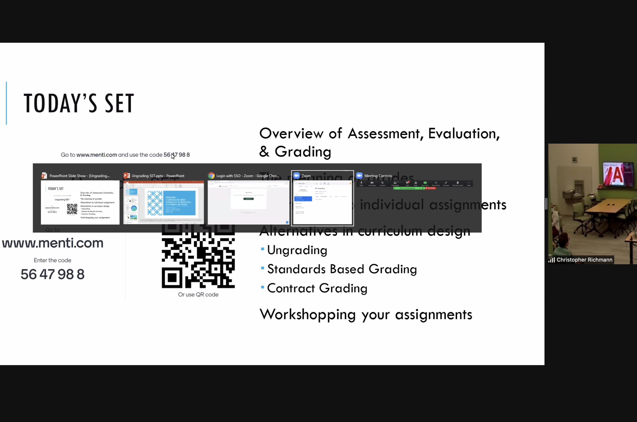

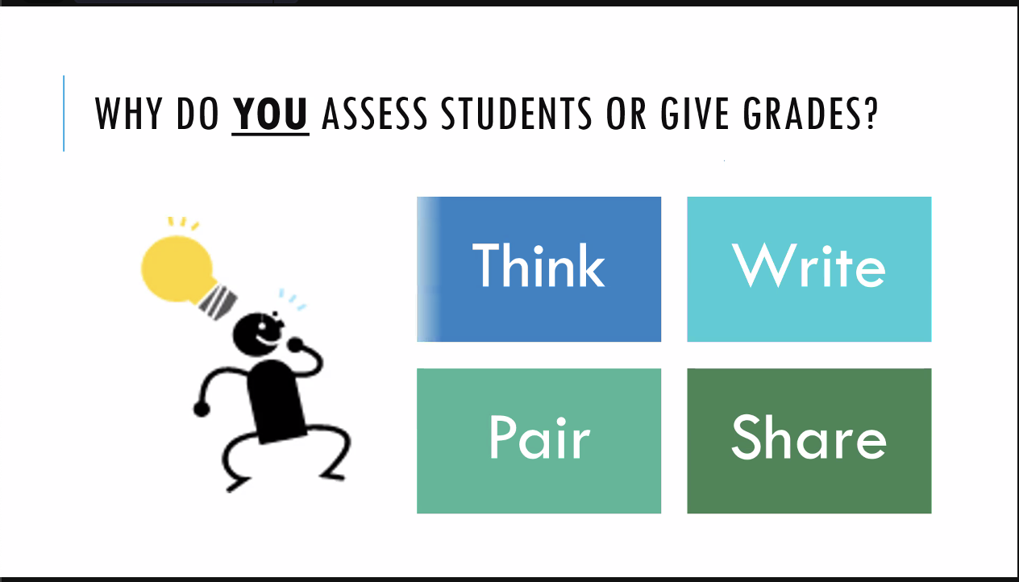

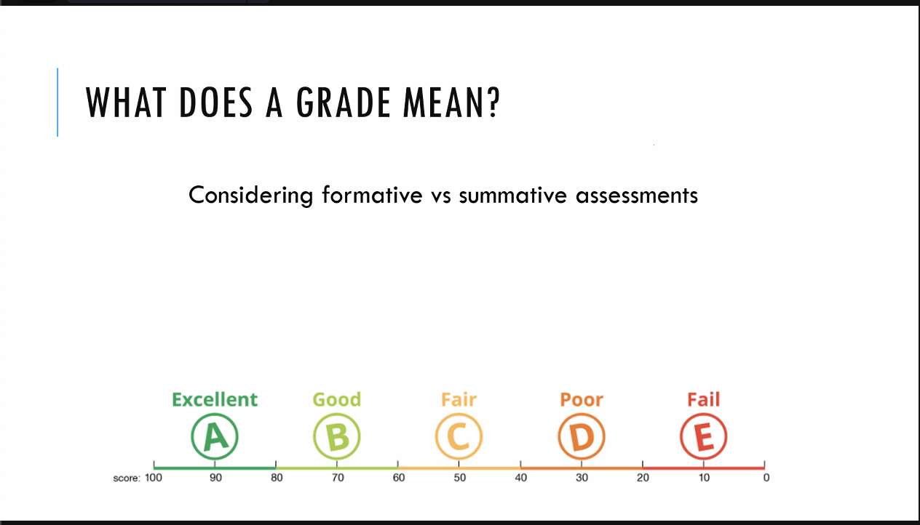

If a grade means you learned a concept, you showed in an exam: when you learn the concept, can you take the exam again and be regraded?

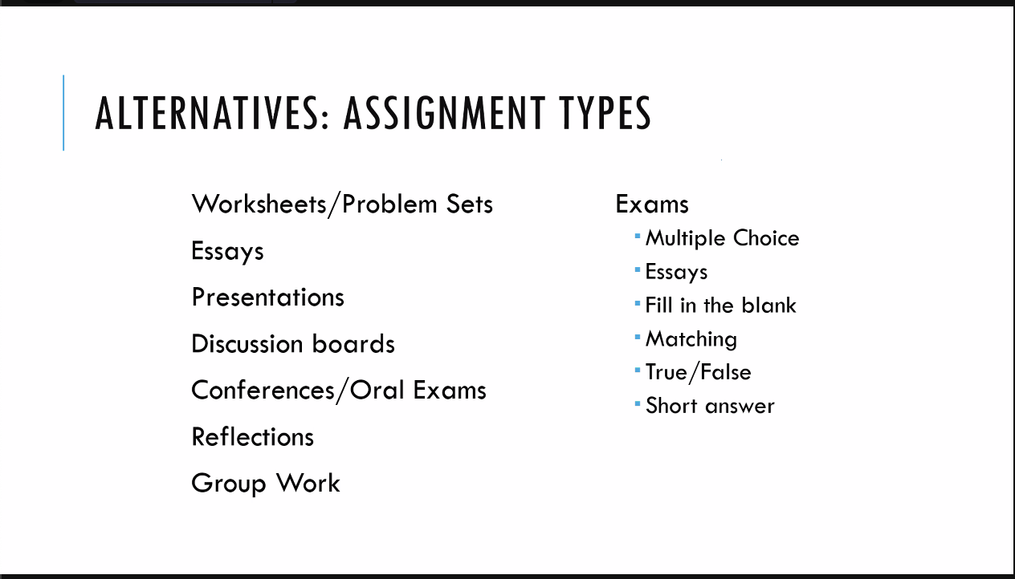

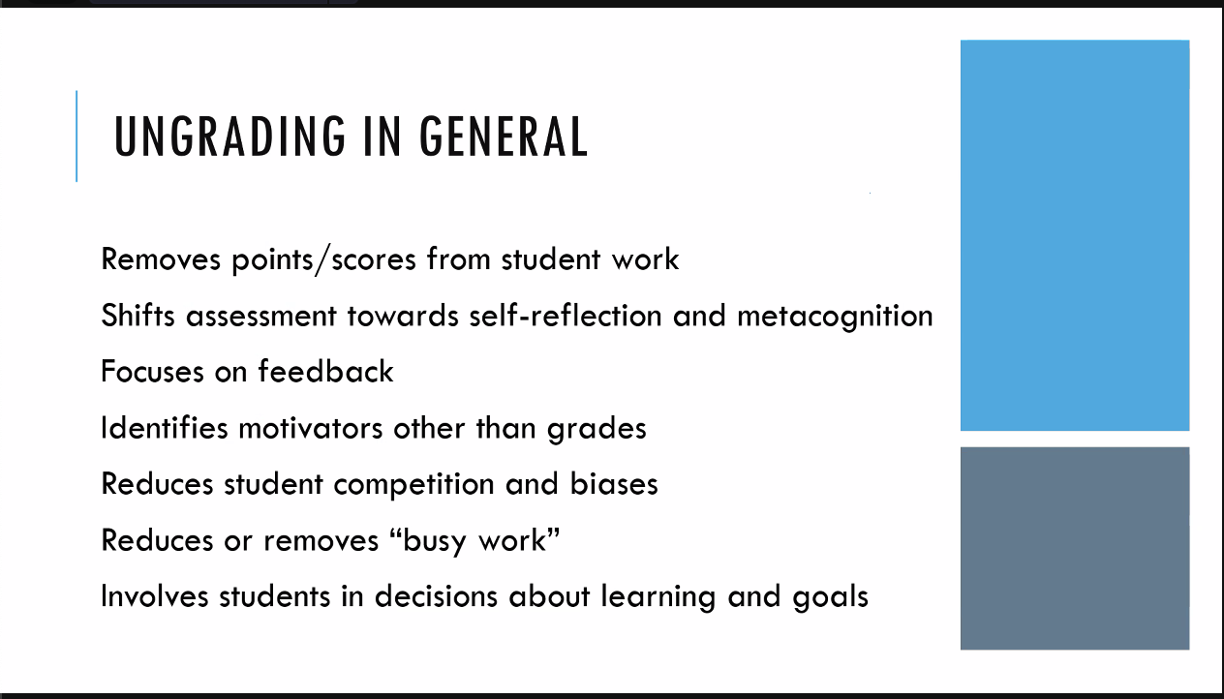

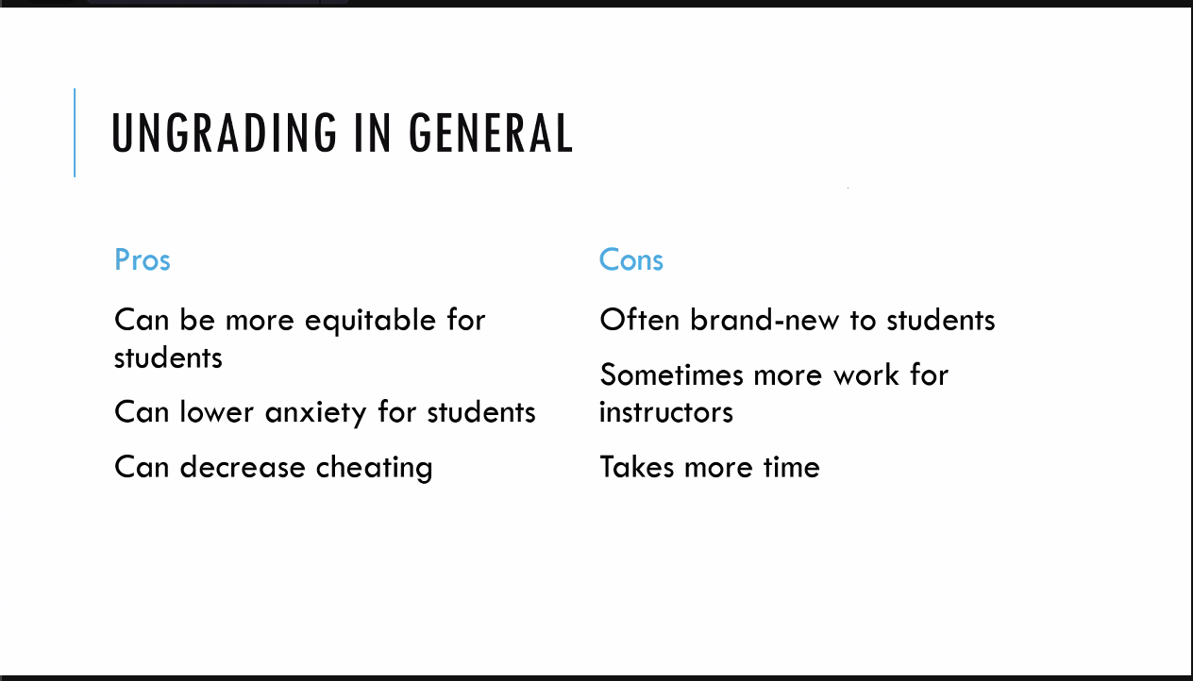

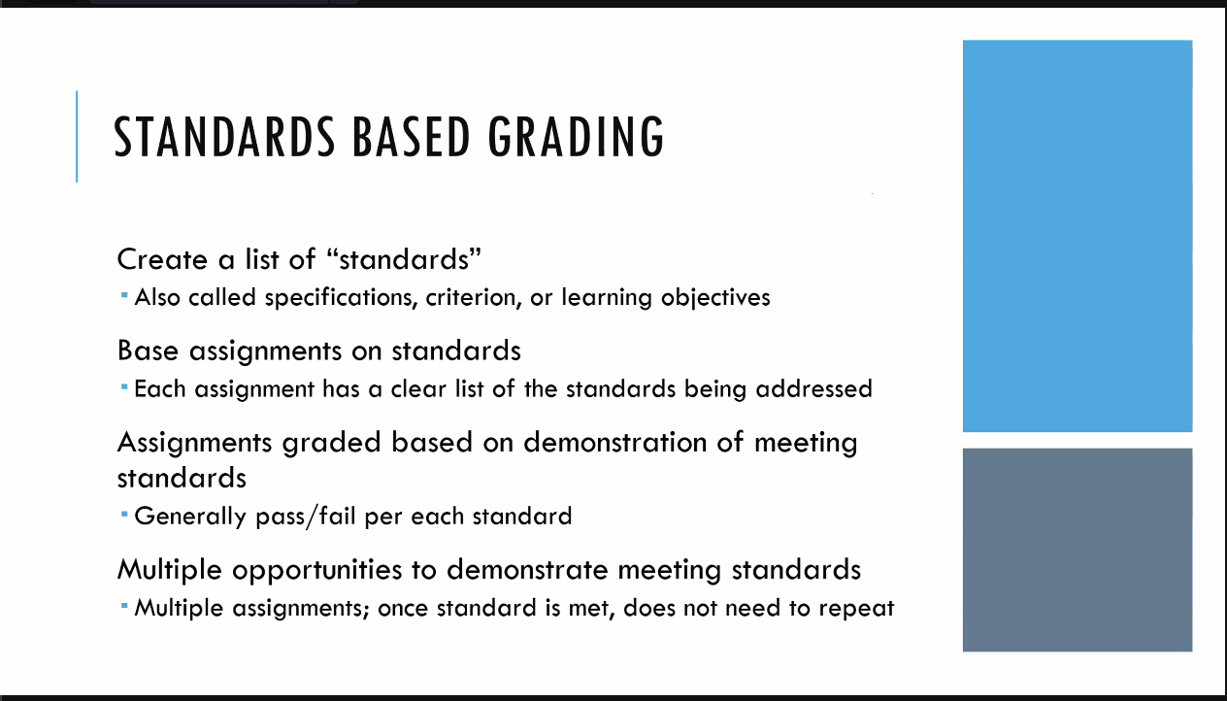

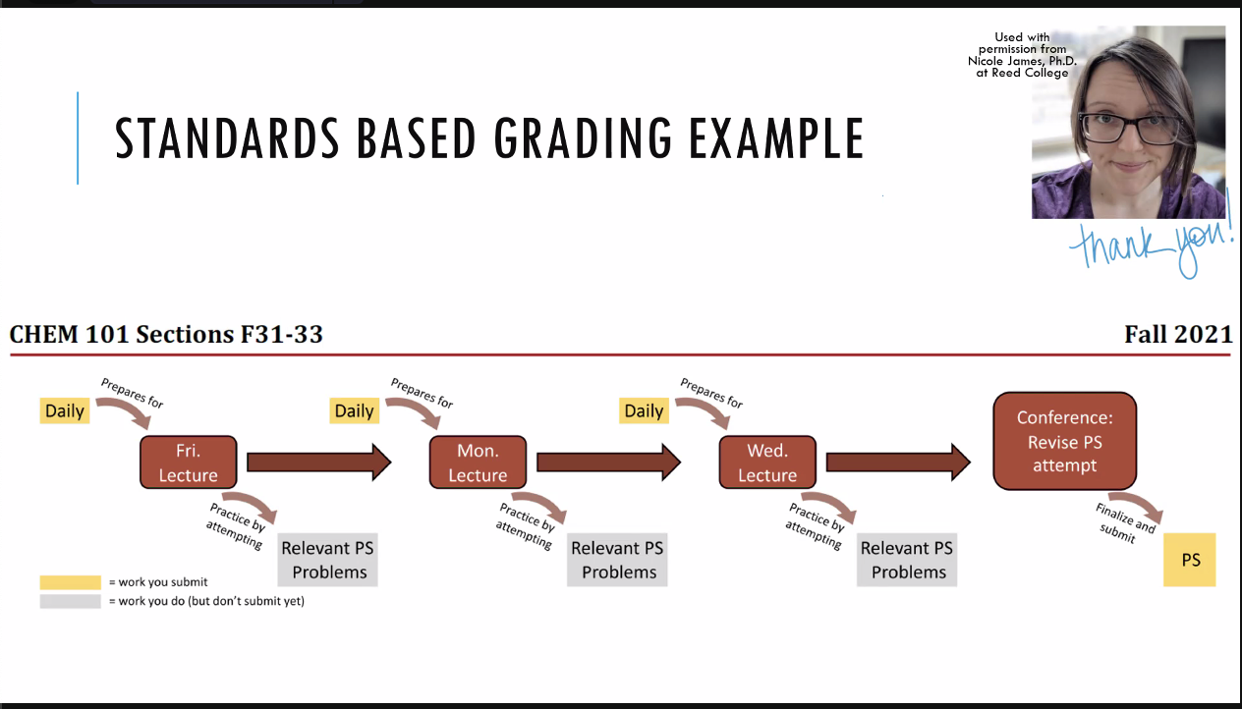

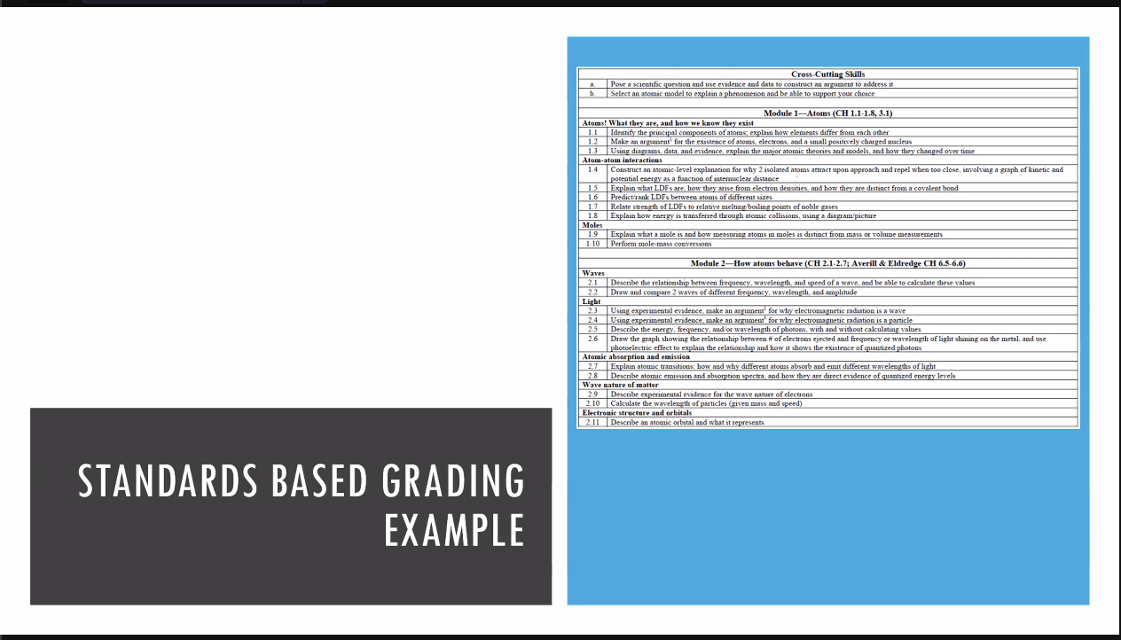

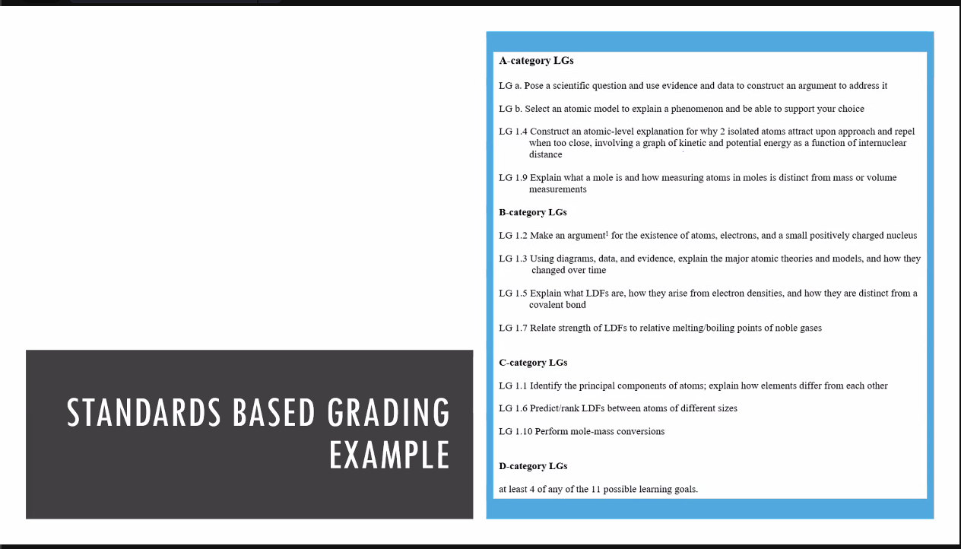

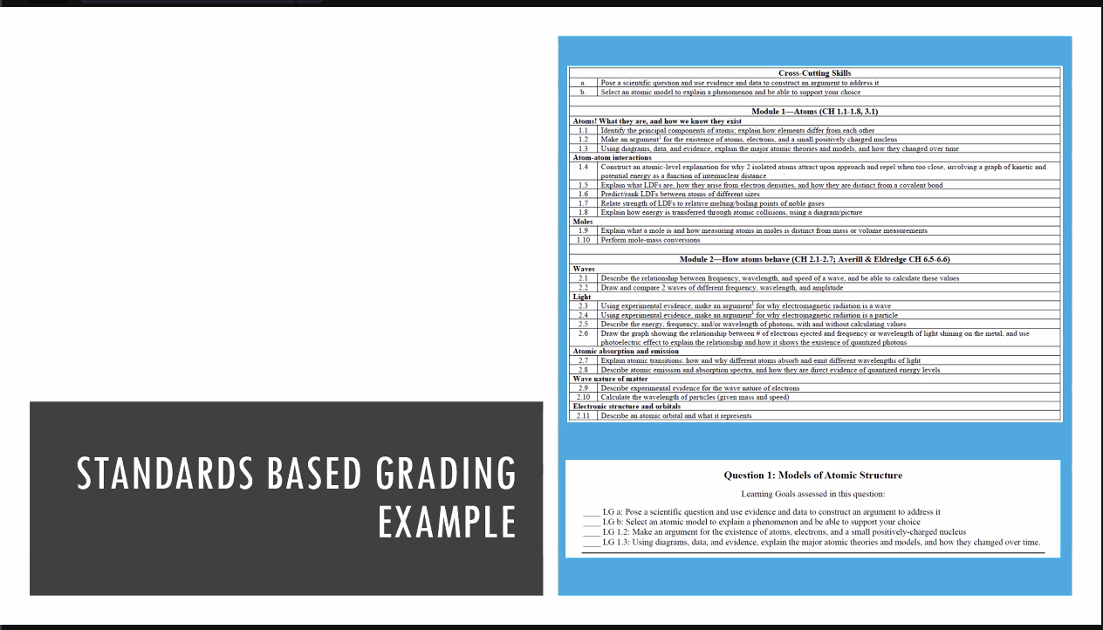

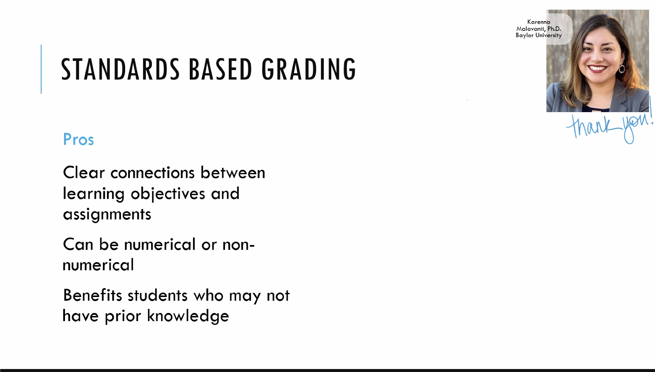

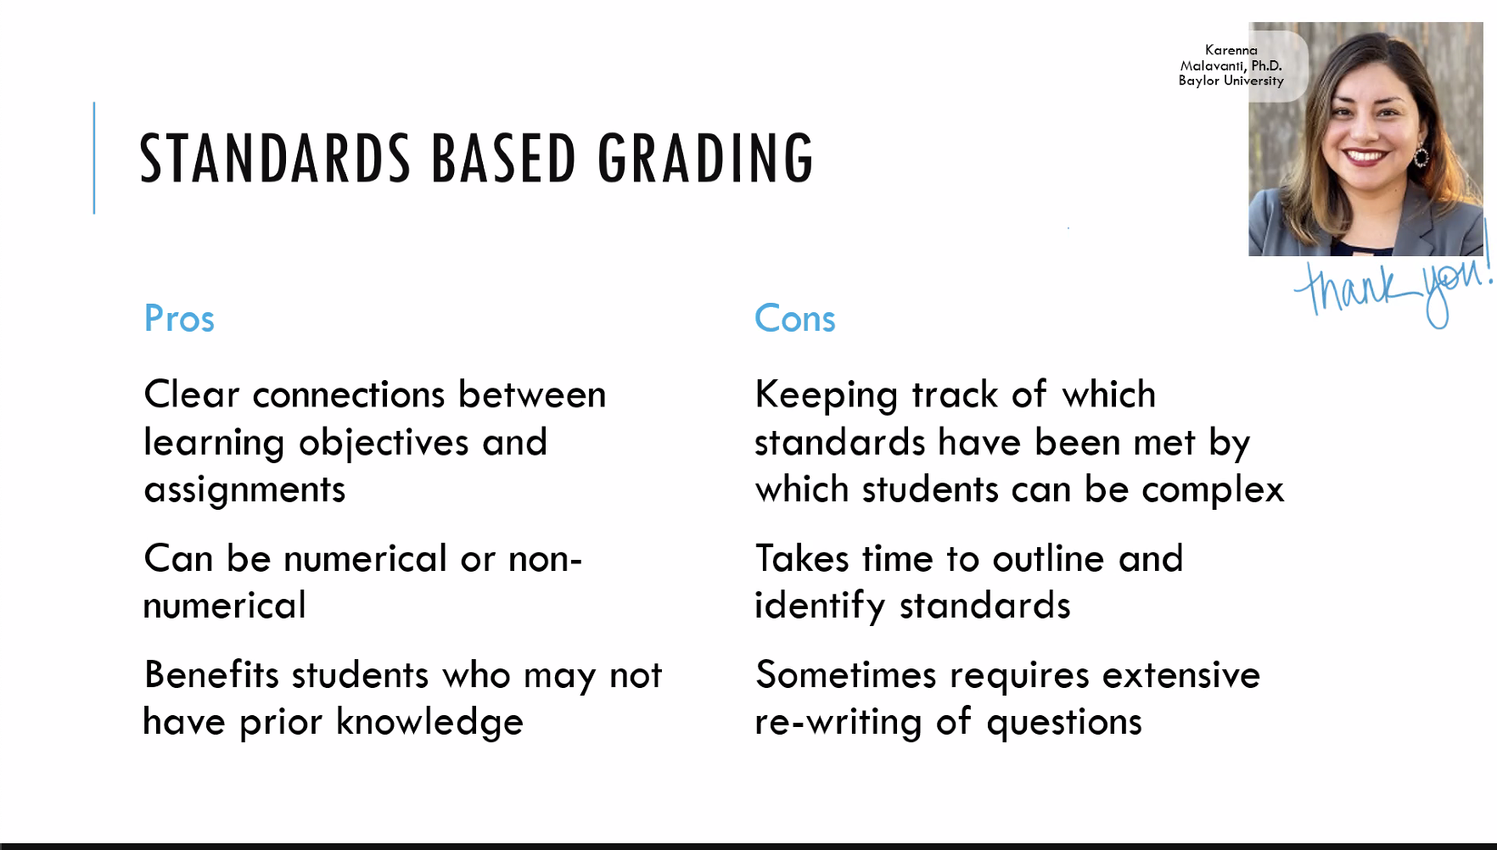

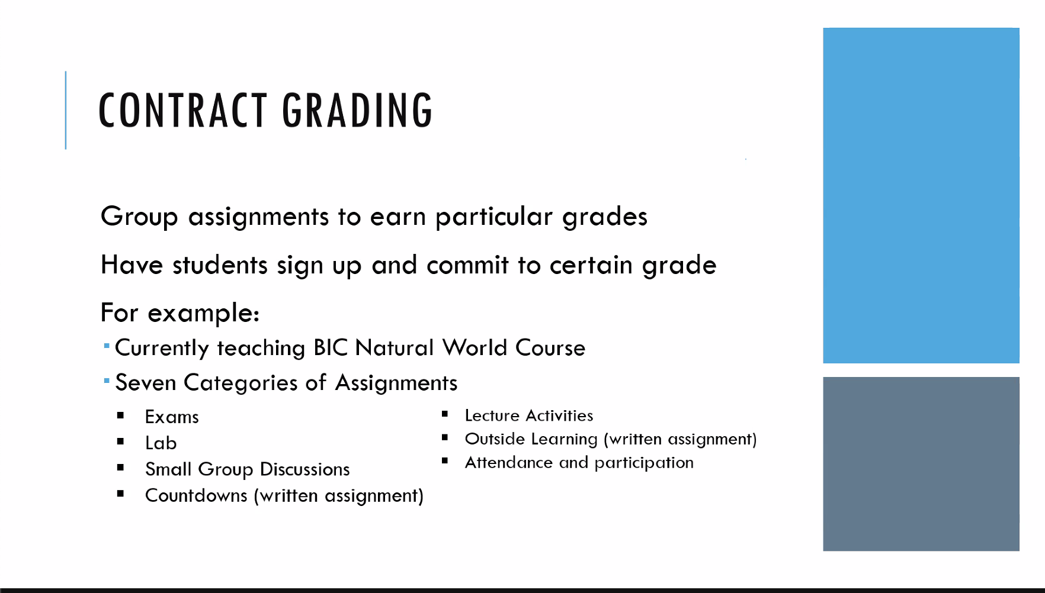

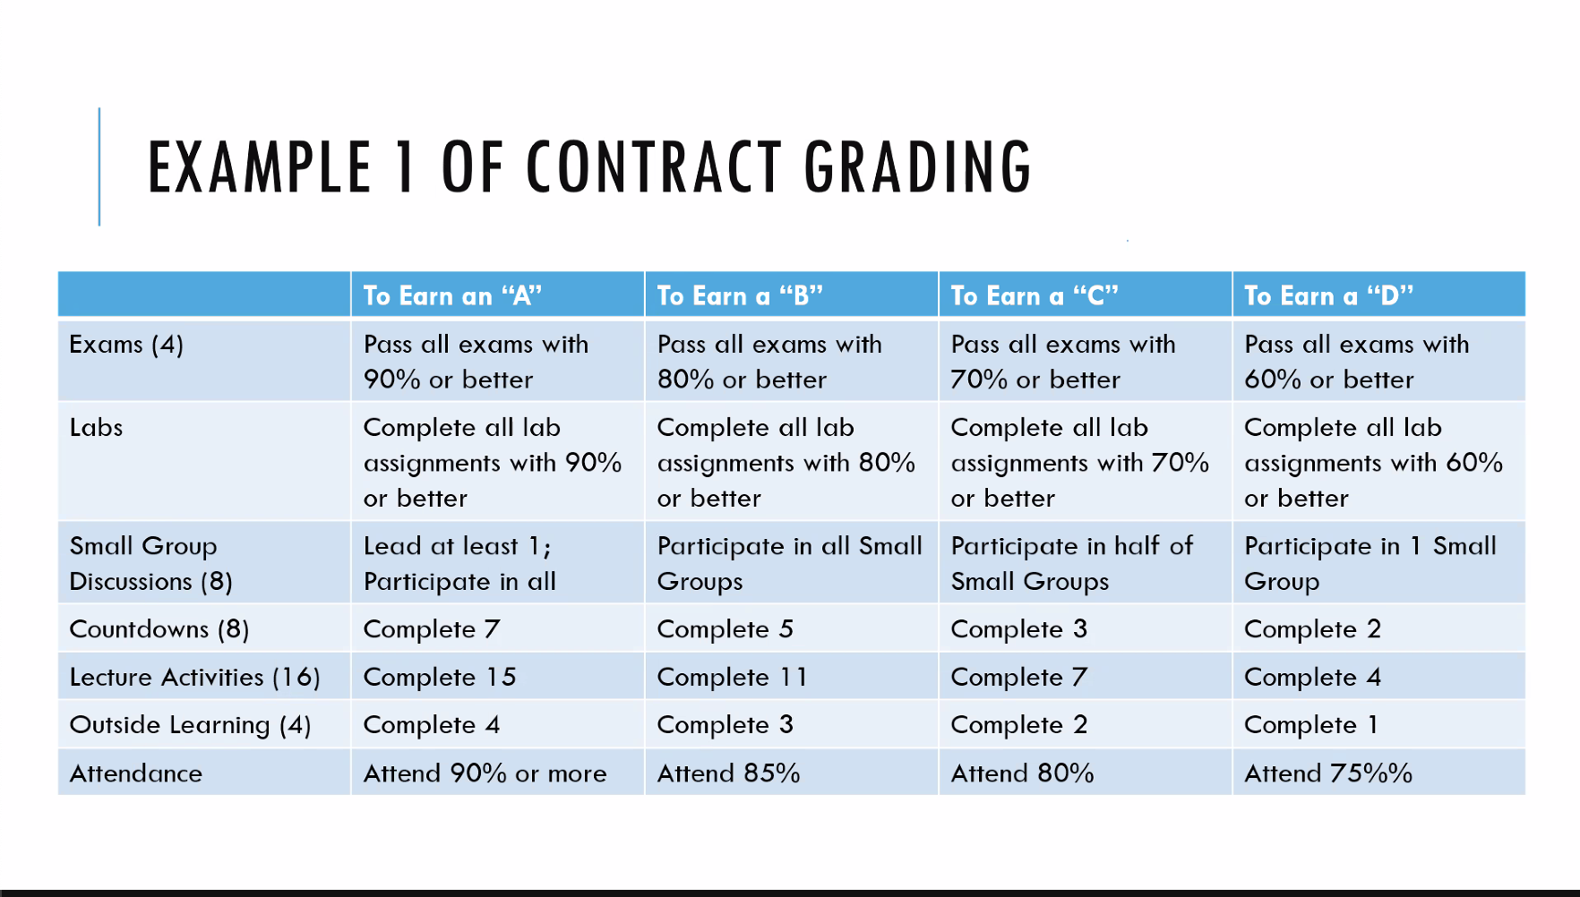

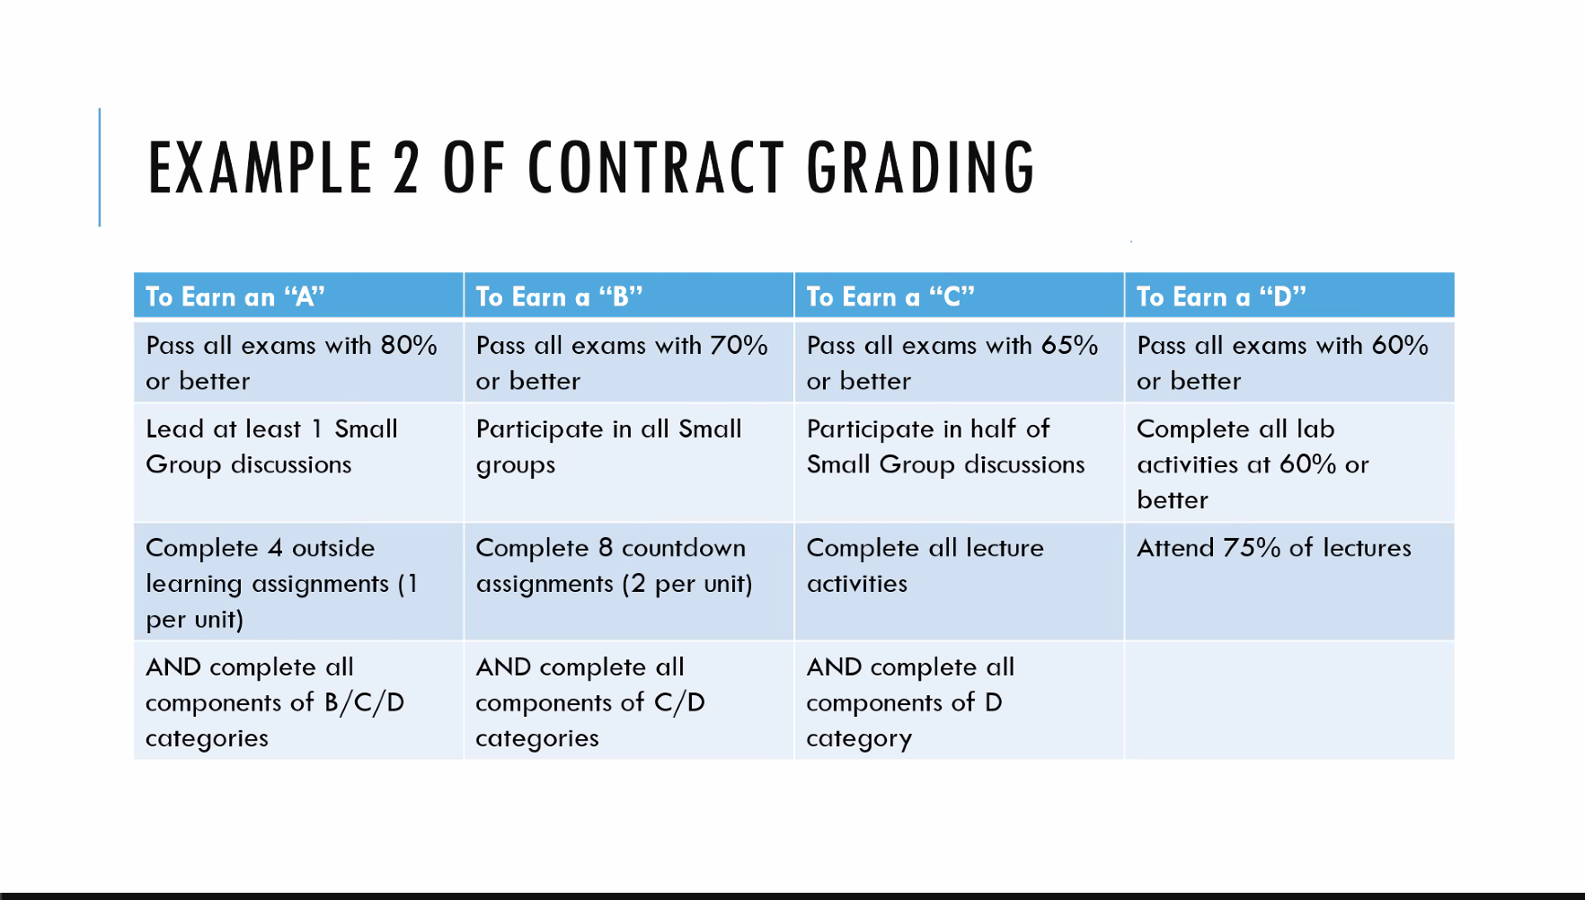

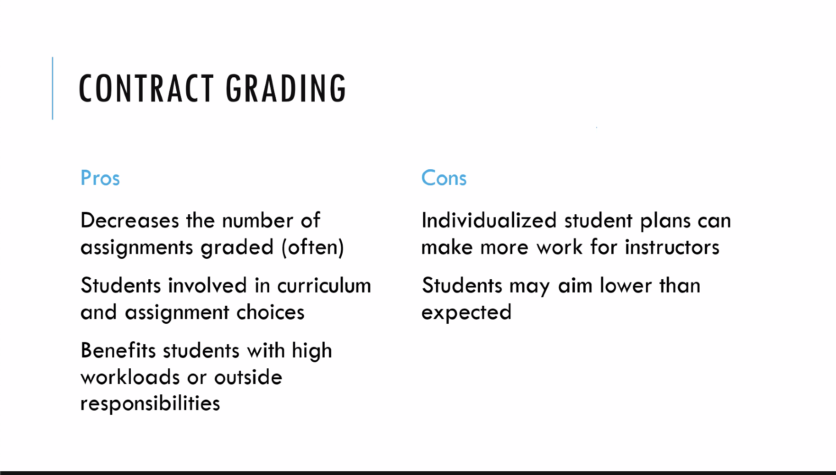

not as excited as me

why I want o teach

learn what for?

what to learn?

challenge of social community leadership

revise and resubmit

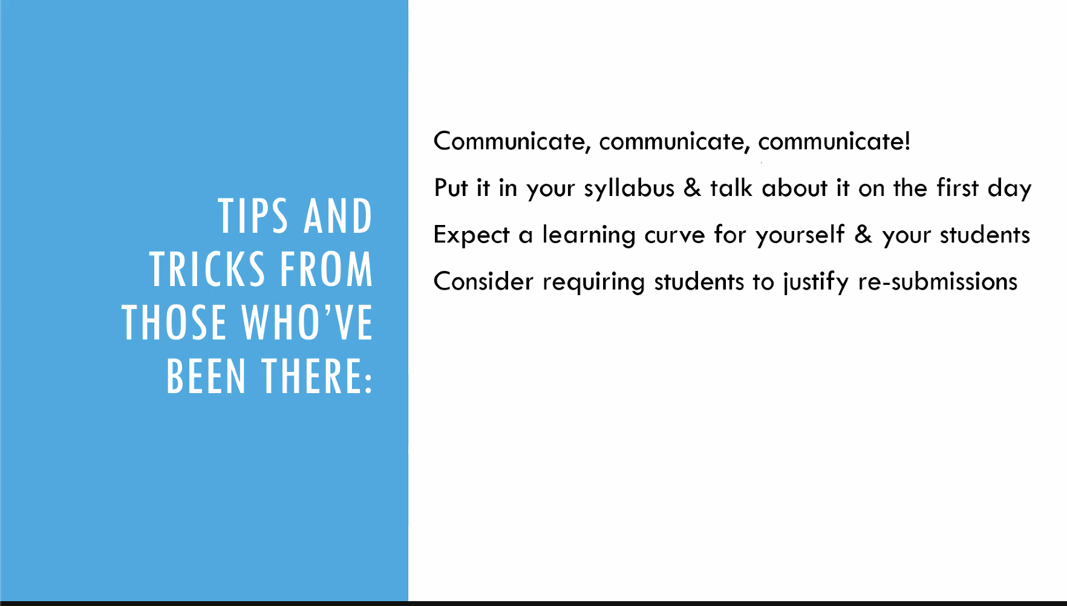

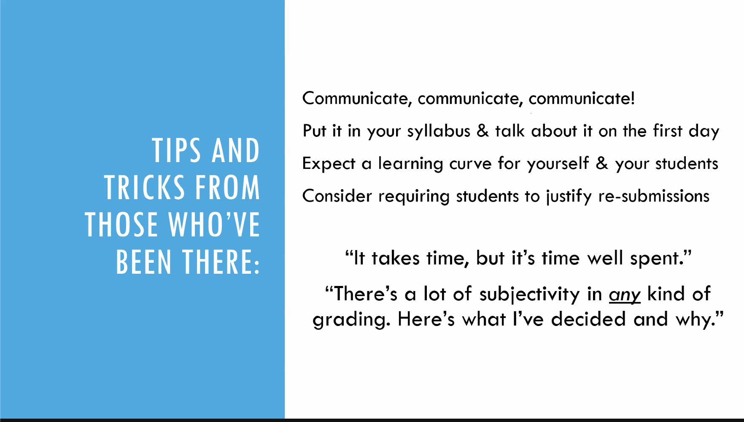

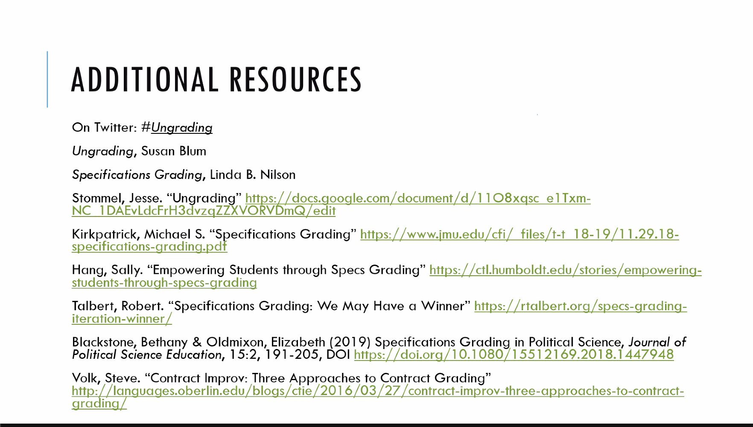

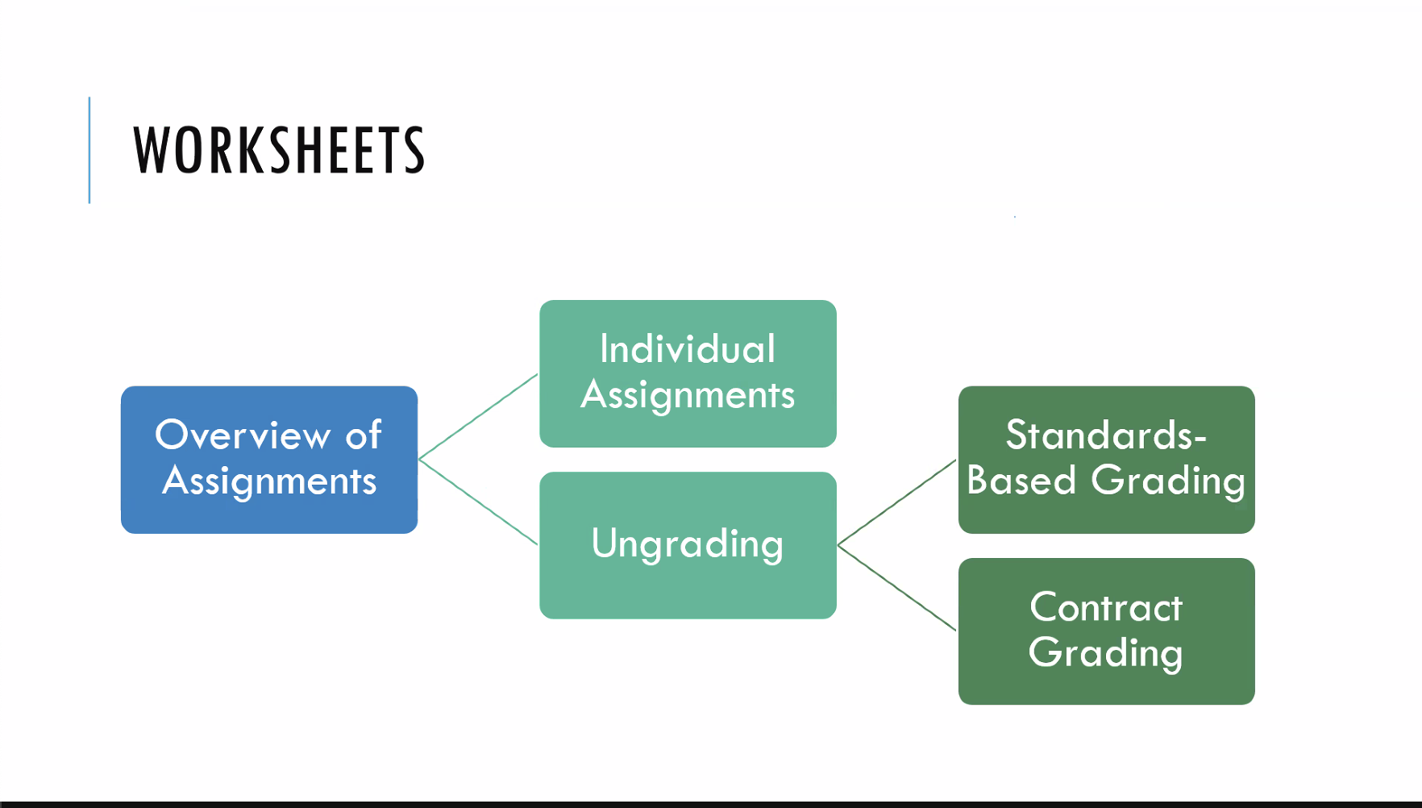

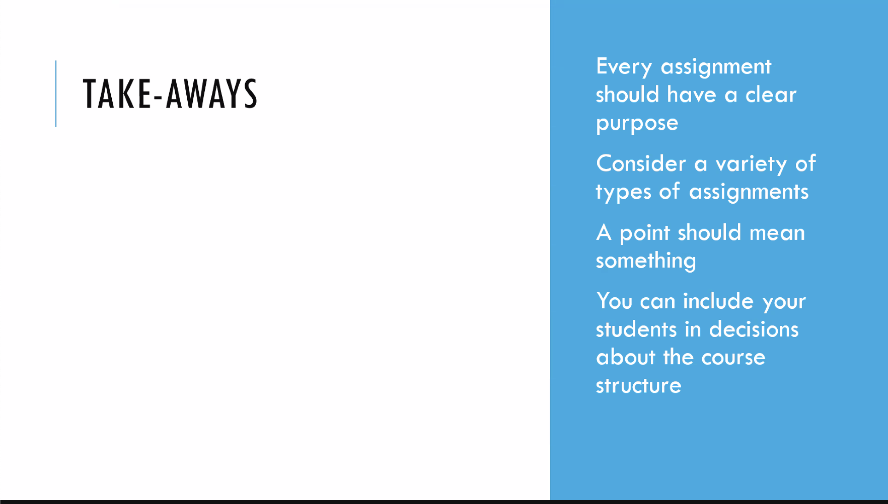

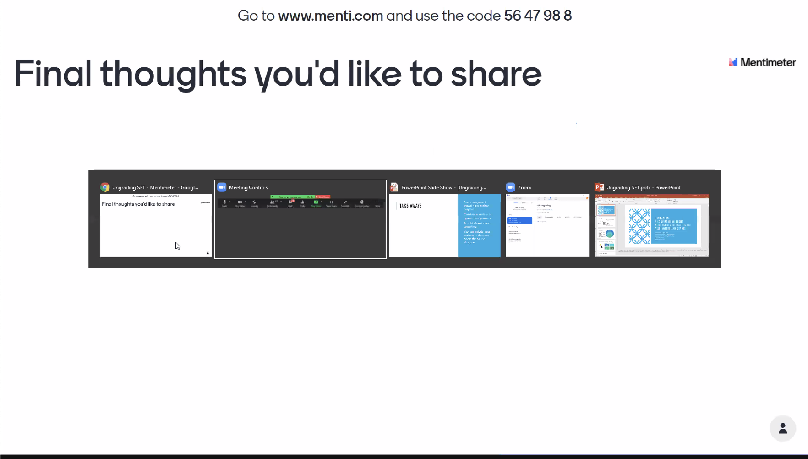

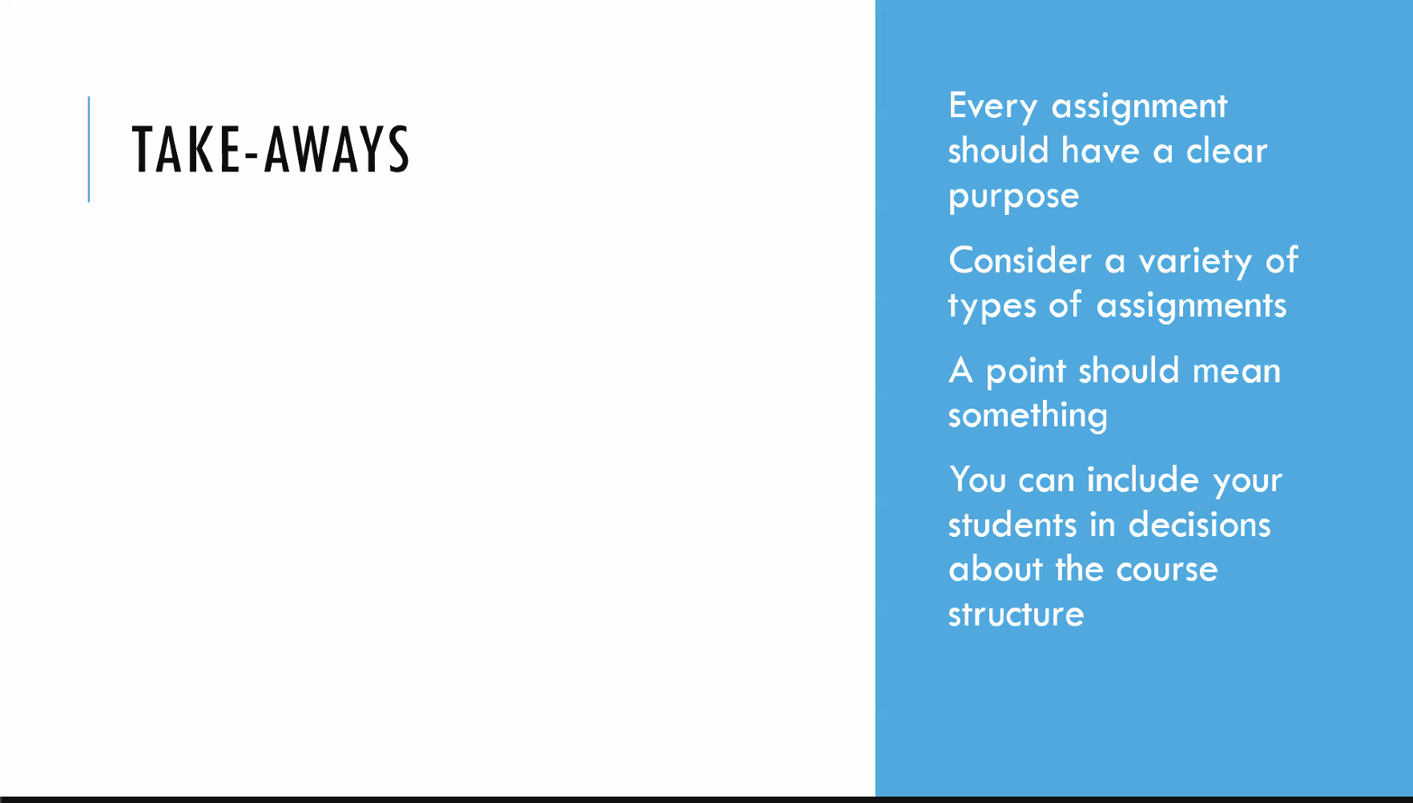

Donna Ward to Everyone (11:05)

We cannot see the code

Poonam J. Bhakta to Everyone (11:05)

5647988

Karenna Malavanti to Everyone (11:05)

www.menti.com

Donna Ward to Everyone (11:06)

Thank you!

Dr. Pam Manhart to Everyone (11:06)

classifying

Me to Everyone (11:06)

Old schoolmalternatives

Christopher Richmann to Everyone (11:10)

Worksheets/handouts for today's session: https://baylor.box.com/s/vspqvcinzd4p9eb3tma11bs57hq6p2zh

Zoom folks--instead of "pairing," go ahead and put your thoughts in the chat: "why do you assess students or give grades?"

Lara Hwa to Everyone (11:12)

To have a metric for learning objectives

Kayla Gilley to Everyone (11:12)

For me it is mainly to assess where my students understand and don’t understand the material.

Me to Everyone (11:12)

I have mostly graded for administrative requirement

Donna Ward to Everyone (11:12)

Determine what students know and still need to know about their learning in the content area

Dr. Pam Manhart to Everyone (11:13)

To give them feedback and also get feedback about what areas need more explanation or coverage

Andrew Sutherland to Everyone (11:13)

I first thought of grades as a way to give feedback, but I realized that they are more an occasion for feedback, not feedback themselves… After that, I landed on grades as a form of accountability

Sarah Tharp to Everyone (11:13)

I mostly give grades because that is the system that we have for assessment in the courses I teach; I do like students to have a sense for how they are doing, but sometimes grades don’t match their knowledge or effort, which is frustrating

Donna Ward to Everyone (11:13)

Determine how to adjust teaching to reteach concepts most students did not understand

Meredith Palm to Everyone (11:13)

I grade because I feel like I have to. It’s only one way of providing feedback, and doesn’t always holistically address a student’s understanding of the learning objective

Rob Rogers (he, him) to Everyone (11:13)

Help students stay engaged in their learning by providing feedback about their work

Mary McCulley to Everyone (11:13)

Keep students accountable for reading and discussion and to measure whether students can demonstrate critical thinking skills.

Donna Ward to Everyone (11:14)

Grades should be a reflection of the learning. Most teachers give a grade that reflects the students behaviors (not turning in assignments, not giving effort) rather than on what the student actually knows.

Karenna Malavanti to Everyone (11:14)

To get feedback from students on what they have learned and where they are struggling. Ultimately, to be able to better meet students where they are and help them with where they want to go (content mastery, etc)

Me to Everyone (11:14)

I think evaluation and feedback are not grades

Donna Ward to Everyone (11:14)

Provide interventions to students who need more support

Bud Esserman to Everyone (11:14)

Accountability and measurement

Dr. Pam Manhart to Everyone (11:14)

Accountability is a good one. Assignments also create a schedule to motivate students to keep up

Lee Anne Brannon to Everyone (11:14)

To check for understanding

Rob Rogers (he, him) to Everyone (11:15)

I avoid giving grades unless it seems necessary and focus on providing individualized feedback on students' work.

Lee Anne Brannon to Everyone (11:15)

To revise our teaching based on their progress

Me to Everyone (11:16)

Feedback, progress, motivation, encouragement, sound to me kind of far from grades

Danielle Williams to Everyone (11:16)

I agree with @Juan Carlos. I love feedback, but grades are something else

Me to Everyone (11:21)

I have done it before thinking more on education

Me to Everyone (11:23)

If a grade means you learned a concept, you showed it in an exam: when you learn the concept, can you take the exam again and be regraded?

Karenna Malavanti to Everyone (11:24)

I really like Specs grading: https://www.insidehighered.com/views/2016/01/19/new-ways-grade-more-effectively-essay

Alexandra Romanyshyn (she/her/hers) to Everyone (11:26)

I’ve both taken and given oral exams, and I think they’re great—students get nervous because they’re not used to it but they tend to do better than on a written exam, in my experience

Karenna Malavanti to Everyone (11:27)

Especially with clear guidelines (specifications), this reduces student anxiety and reduces the burden of point by point grading

Me to Everyone (11:27)

Collective valuation, I lived that some time when studying theology: it was amazing!

Collective Evaluation*

Donna Ward to Everyone (11:51)

very interesting topic

Christopher Richmann to Everyone (11:53)

Zoomers--feel free to put any questions for Michelle in the chat.

Christopher Richmann to Everyone (11:54)

We’d be grateful if you could take 2 minutes to give your feedback on this survey: https://baylor.qualtrics.com/jfe/form/SV_7VZ4jSA9awy1Phk

Me to Everyone (11:55)

How do you see the pass/fail scale? I have the feeling that we need something to get some distance from numeric grading to more significant ways of evaluation-motivation

Hugh Riley to Everyone (11:55)

What about administering essay exams for those wanting an A in a course and administering only multiple choice questions for those who want a B or lower?

Rob Rogers (he, him) to Everyone (11:55)

Will you be sending your PPT to participants via email?

Christopher Richmann to Everyone (11:56)

Rob-yes, I'll send out the slides. Thanks!

Me to Everyone (11:56)

Thanks for asking, Rob!

Christopher Richmann to Everyone (11:58)

We’d be grateful if you could take 2 minutes to give your feedback on this survey: https://baylor.qualtrics.com/jfe/form/SV_7VZ4jSA9awy1Phk

Donna Ward to Everyone (11:05)

We cannot see the code

Poonam J. Bhakta to Everyone (11:05)

5647988

Karenna Malavanti to Everyone (11:05)

www.menti.com

Donna Ward to Everyone (11:06)

Thank you!

Dr. Pam Manhart to Everyone (11:06)

classifying

Me to Everyone (11:06)

Old schoolmalternatives

Christopher Richmann to Everyone (11:10)

Worksheets/handouts for today's session: https://baylor.box.com/s/vspqvcinzd4p9eb3tma11bs57hq6p2zh

Zoom folks--instead of "pairing," go ahead and put your thoughts in the chat: "why do you assess students or give grades?"

Lara Hwa to Everyone (11:12)

To have a metric for learning objectives

Kayla Gilley to Everyone (11:12)

For me it is mainly to assess where my students understand and don’t understand the material.

Me to Everyone (11:12)

I have mostly graded for administrative requirement

Donna Ward to Everyone (11:12)

Determine what students know and still need to know about their learning in the content area

Dr. Pam Manhart to Everyone (11:13)

To give them feedback and also get feedback about what areas need more explanation or coverage

Andrew Sutherland to Everyone (11:13)

I first thought of grades as a way to give feedback, but I realized that they are more an occasion for feedback, not feedback themselves… After that, I landed on grades as a form of accountability

Sarah Tharp to Everyone (11:13)

I mostly give grades because that is the system that we have for assessment in the courses I teach; I do like students to have a sense for how they are doing, but sometimes grades don’t match their knowledge or effort, which is frustrating

Donna Ward to Everyone (11:13)

Determine how to adjust teaching to reteach concepts most students did not understand

Meredith Palm to Everyone (11:13)

I grade because I feel like I have to. It’s only one way of providing feedback, and doesn’t always holistically address a student’s understanding of the learning objective

Rob Rogers (he, him) to Everyone (11:13)

Help students stay engaged in their learning by providing feedback about their work

Mary McCulley to Everyone (11:13)

Keep students accountable for reading and discussion and to measure whether students can demonstrate critical thinking skills.

Donna Ward to Everyone (11:14)

Grades should be a reflection of the learning. Most teachers give a grade that reflects the students behaviors (not turning in assignments, not giving effort) rather than on what the student actually knows.

Karenna Malavanti to Everyone (11:14)

To get feedback from students on what they have learned and where they are struggling. Ultimately, to be able to better meet students where they are and help them with where they want to go (content mastery, etc)

Me to Everyone (11:14)

I think evaluation and feedback are not grades

Donna Ward to Everyone (11:14)

Provide interventions to students who need more support

Bud Esserman to Everyone (11:14)

Accountability and measurement

Dr. Pam Manhart to Everyone (11:14)

Accountability is a good one. Assignments also create a schedule to motivate students to keep up

Lee Anne Brannon to Everyone (11:14)

To check for understanding

Rob Rogers (he, him) to Everyone (11:15)

I avoid giving grades unless it seems necessary and focus on providing individualized feedback on students' work.

Lee Anne Brannon to Everyone (11:15)

To revise our teaching based on their progress

Me to Everyone (11:16)

Feedback, progress, motivation, encouragement, sound to me kind of far from grades

Danielle Williams to Everyone (11:16)

I agree with @Juan Carlos. I love feedback, but grades are something else

Me to Everyone (11:21)

I have done it before thinking more on education

Me to Everyone (11:23)

If a grade means you learned a concept, you showed it in an exam: when you learn the concept, can you take the exam again and be regraded?

Karenna Malavanti to Everyone (11:24)

I really like Specs grading: https://www.insidehighered.com/views/2016/01/19/new-ways-grade-more-effectively-essay

Alexandra Romanyshyn (she/her/hers) to Everyone (11:26)

I’ve both taken and given oral exams, and I think they’re great—students get nervous because they’re not used to it but they tend to do better than on a written exam, in my experience

Karenna Malavanti to Everyone (11:27)

Especially with clear guidelines (specifications), this reduces student anxiety and reduces the burden of point by point grading

Me to Everyone (11:27)

Collective valuation, I lived that some time when studying theology: it was amazing!

Collective Evaluation*

Donna Ward to Everyone (11:51)

very interesting topic

Christopher Richmann to Everyone (11:53)

Zoomers--feel free to put any questions for Michelle in the chat.

Christopher Richmann to Everyone (11:54)

We’d be grateful if you could take 2 minutes to give your feedback on this survey: https://baylor.qualtrics.com/jfe/form/SV_7VZ4jSA9awy1Phk

Me to Everyone (11:55)

How do you see the pass/fail scale? I have the feeling that we need something to get some distance from numeric grading to more significant ways of evaluation-motivation

Hugh Riley to Everyone (11:55)

What about administering essay exams for those wanting an A in a course and administering only multiple choice questions for those who want a B or lower?

Rob Rogers (he, him) to Everyone (11:55)

Will you be sending your PPT to participants via email?

Christopher Richmann to Everyone (11:56)

Rob-yes, I'll send out the slides. Thanks!

Me to Everyone (11:56)

Thanks for asking, Rob!

Christopher Richmann to Everyone (11:58)

We’d be grateful if you could take 2 minutes to give your feedback on this survey: https://baylor.qualtrics.com/jfe/form/SV_7VZ4jSA9awy1Phk

